How to Use the Church Life-Cycles Grid
Objective:
The purpose of this grid is to give you a quick understanding of the current status of your church, and what are the next major steps that will need to be taken to begin to grow, to continue to grow, or to revitalize. This is not intended to be, in any sense, a comprehensive guide to your church. However, it is a good way to see if your Search Team or Leadership Board have some consensus about the current state of the church.

Overview:
The concept of church Life-Cycles is not new or revolutionary. It has many church surveys and academic studies backing up the concept within organizations and churches. If you want to know more about it or to explore the ideas in more detail, please feel free to contact the Fellowship Ministry Centre for help. For now, use the Grid as a simplified tool to help you in your discovery process as you look for a new pastor.

The Grid assumes that every church is situated somewhere on a Life-Cycle graph. You are not a better or worse church because of where you are located, but you do have specific needs based upon your general situation. A Life-Cycle looks like this:

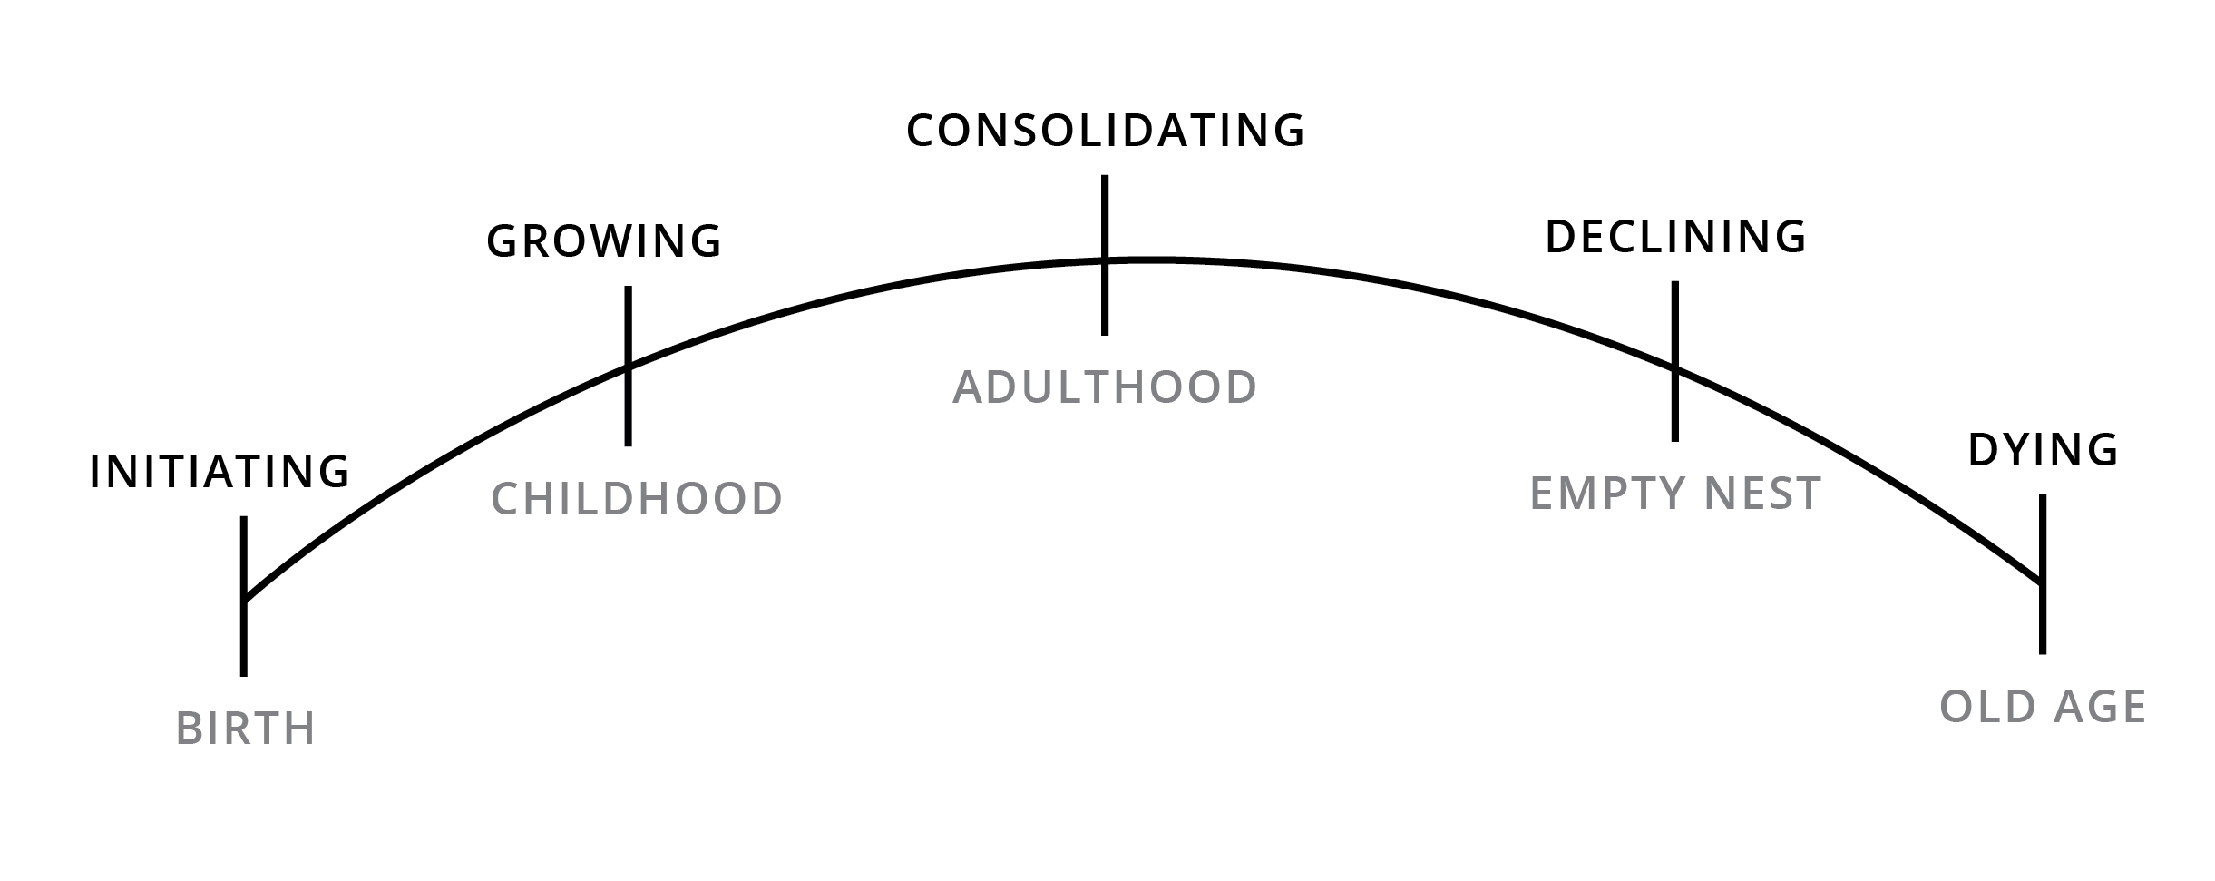

The top line (initiating, growing, consolidating, declining, or dying) is an overall indicator of the status of the church. Each stage requires a particular kind of leadership and direction. The following grid will give you some basics with regard to this.
Old Age

Life-Cycle Basics: The following are some key facts about Life-Cycles:

- No church fits into any category exactly – there are always crossover of characteristics.
- The rate at which churches pass through the life-cycle stages differ greatly, based on a number of factors including staffing, funding, age, leadership, and possible crises.
- While we define a church’s place on the life-cycle based on a variety of characteristics, the PRIMARY determinant is the ability to achieve the church mission through the delivery of effective ministry.
- Appropriate strategies at one stage may (or may not) be appropriate for the next, thus it is not unusual for a church to end a phase with a crisis due to outmoded methods of behavior.
- Any church that wants to succeed in mission must achieve maturity, and then sustain itself in maturity through redefinition and renewal.

How to Use the Following Grid:

- Make copies available to all members of the Search Team and/or Leadership Board.
- Looking at only the first page, have individuals circle the characteristics of a particular stage that most reflect the current realities in your church. For example, look at the first horizontal row regarding Mission and Purpose. Have people read across the row, and circle the characteristics of Mission and Purpose that sound most like your church.
- Then do the same thing for each of the characteristics: Mission and Purpose, Worship and Attendance, Involvement of People, etc..
- Have healthy discussion among your team as to where you think your church is situated in the Life Cycle stages. Remember that there will never be a “perfect” match and that various people will have various opinions.
- Once you have a general consensus on where your church most fits on the grid, look on the second page of the grid. Check again to see if the “Behaviors” you see are somewhat reflective of your church. Check to see if the “Issues That Emerge” are legitimate for your church.
- Then, lastly, look at the bottom row on “What Needs to be Done.”
- Use the information you glean to help you as you determine what kind of leader you should be looking for as your church moves forward. Please remember that you will never get everything you are looking for!
